A(1)

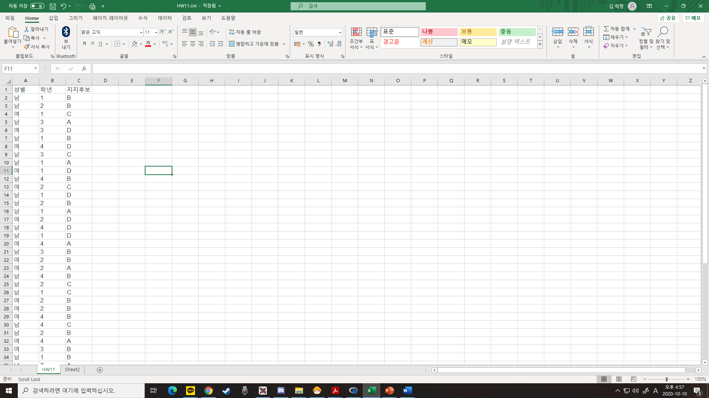

A(2)

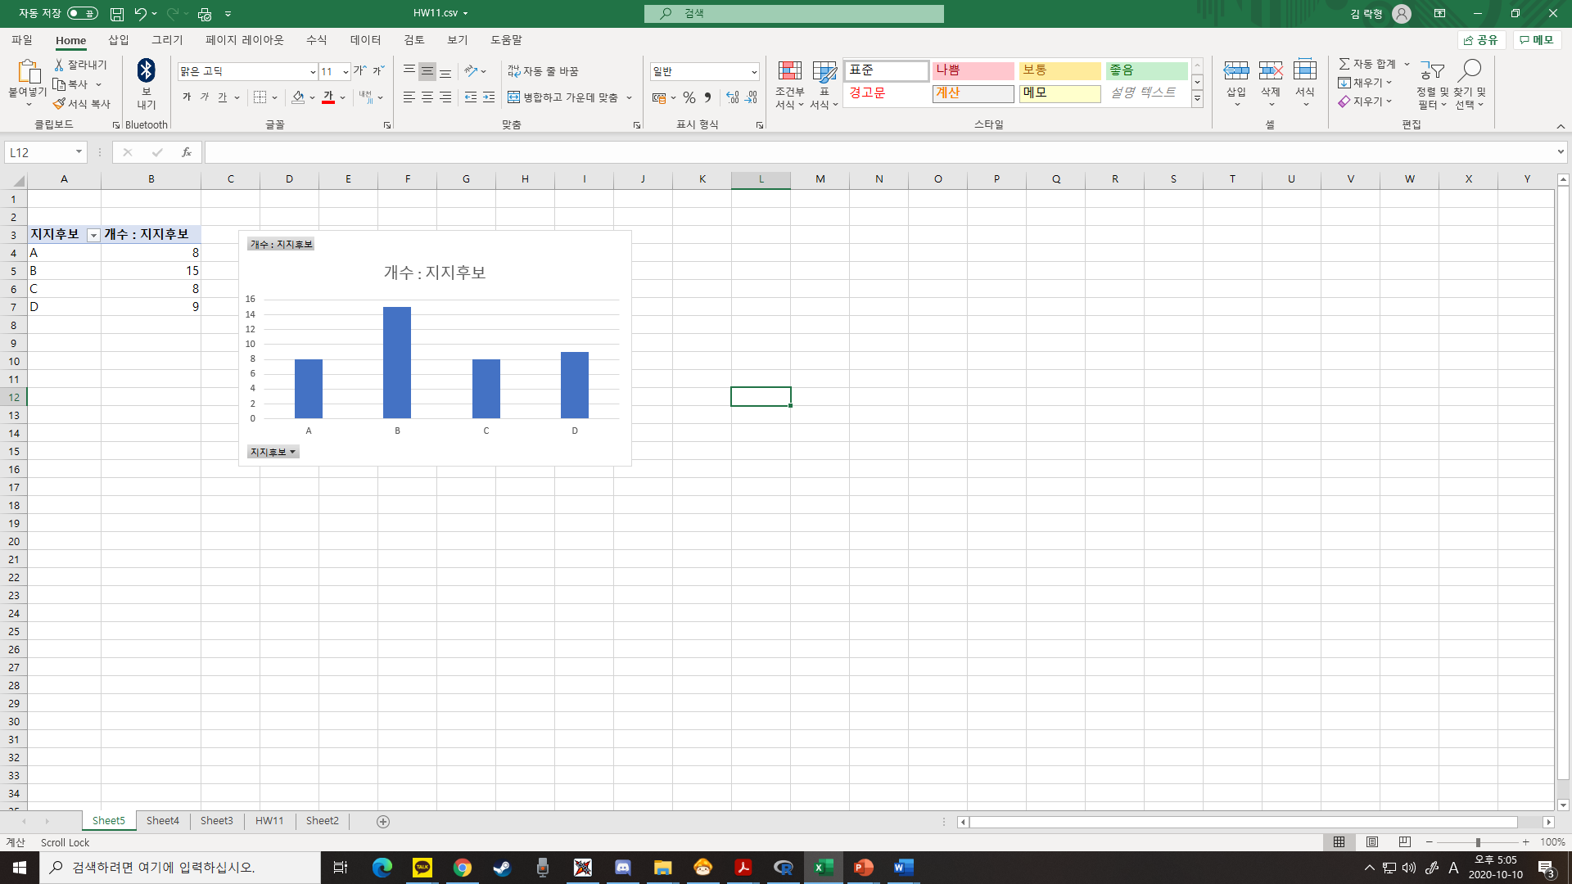

A(3)

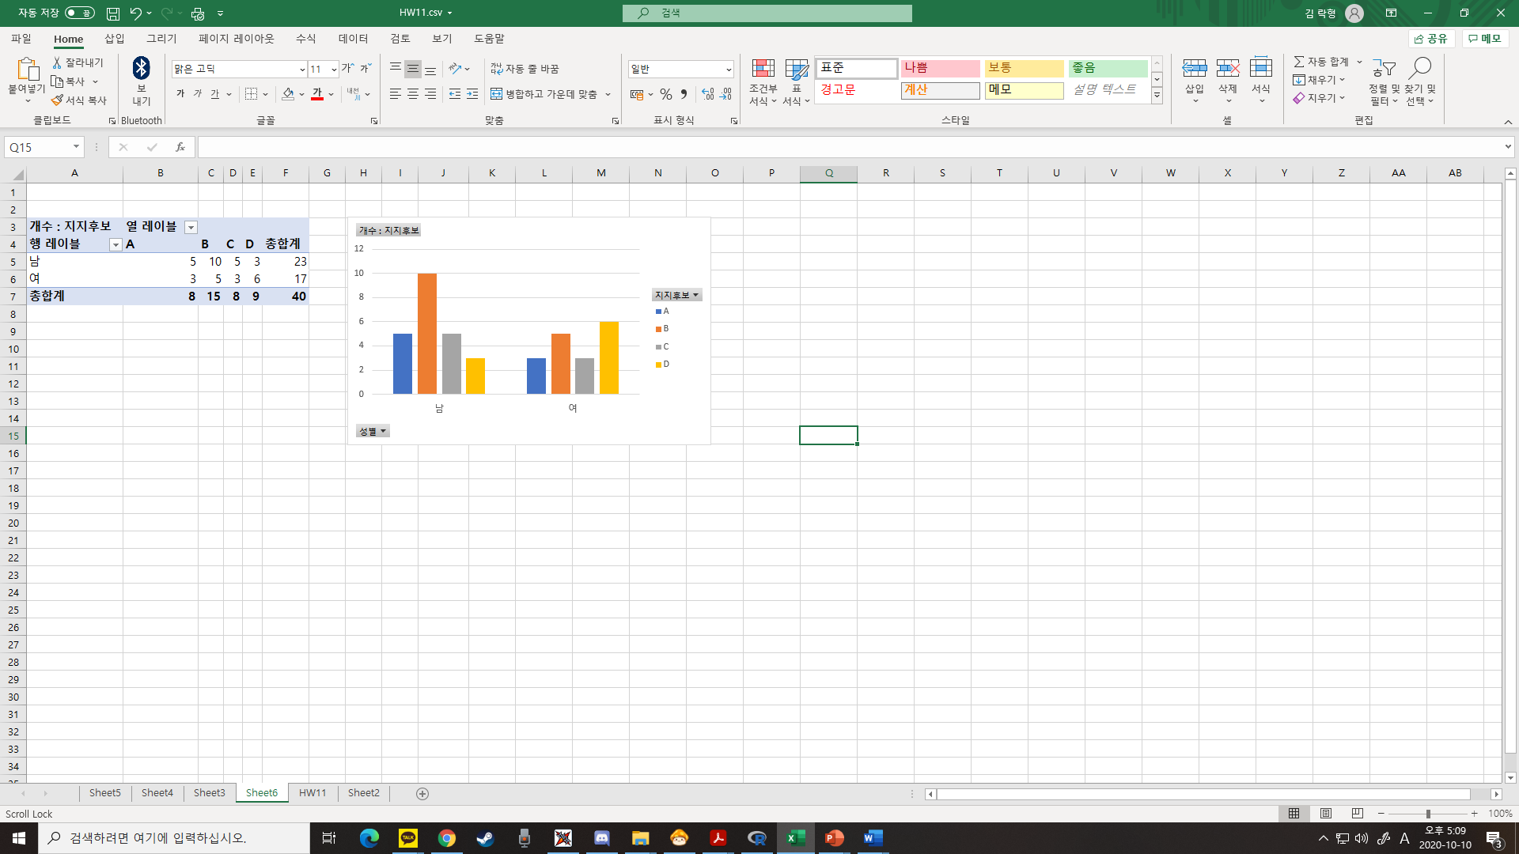

A(4)

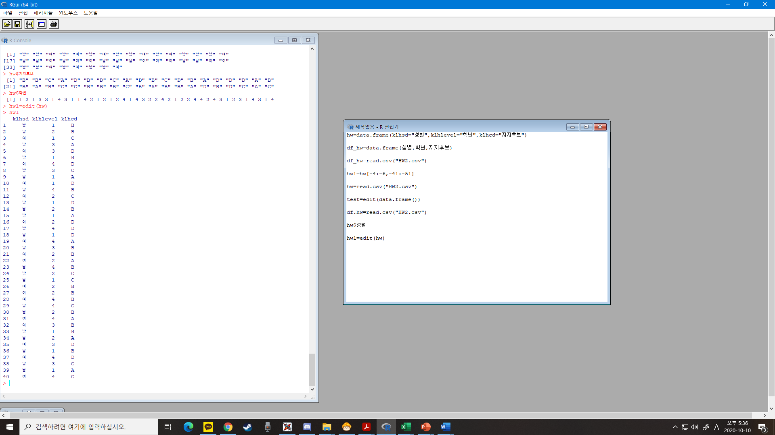

hw=read.csv("HW2.csv")

hw1=edit(hw)

hw1

A(5)

hw1r=table(hw1$klhcd)

hw1.names=c("A","B","C","D")

pie(hw1r\*100,

label=paste(hw1.names,"(",hw1r\*100,"%)"),

col=c("yellow","green","skyblue","blue"),

clockwise=T,main="지지후보(%)")

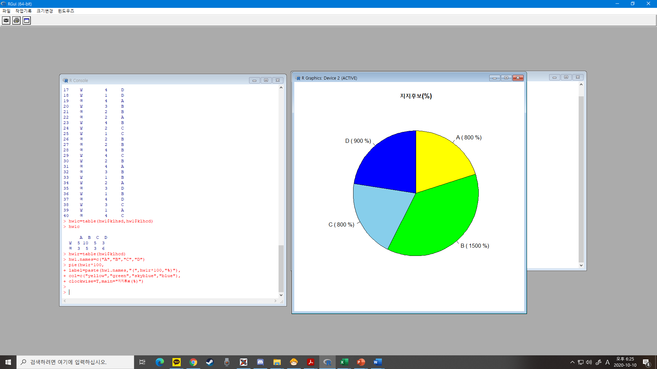

A(6)

> hw1c=table(hw1$klhsd,hw1$klhcd)

> hw1c

A B C D

남 5 10 5 3

여 3 5 3 6

B(1)



B(2)

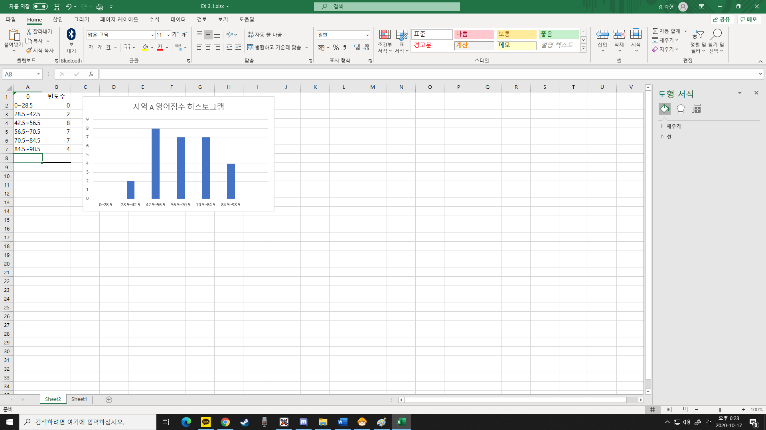

B(3)

EX=read.csv("EX3.1R.csv")

klhdf2=edit(EX)

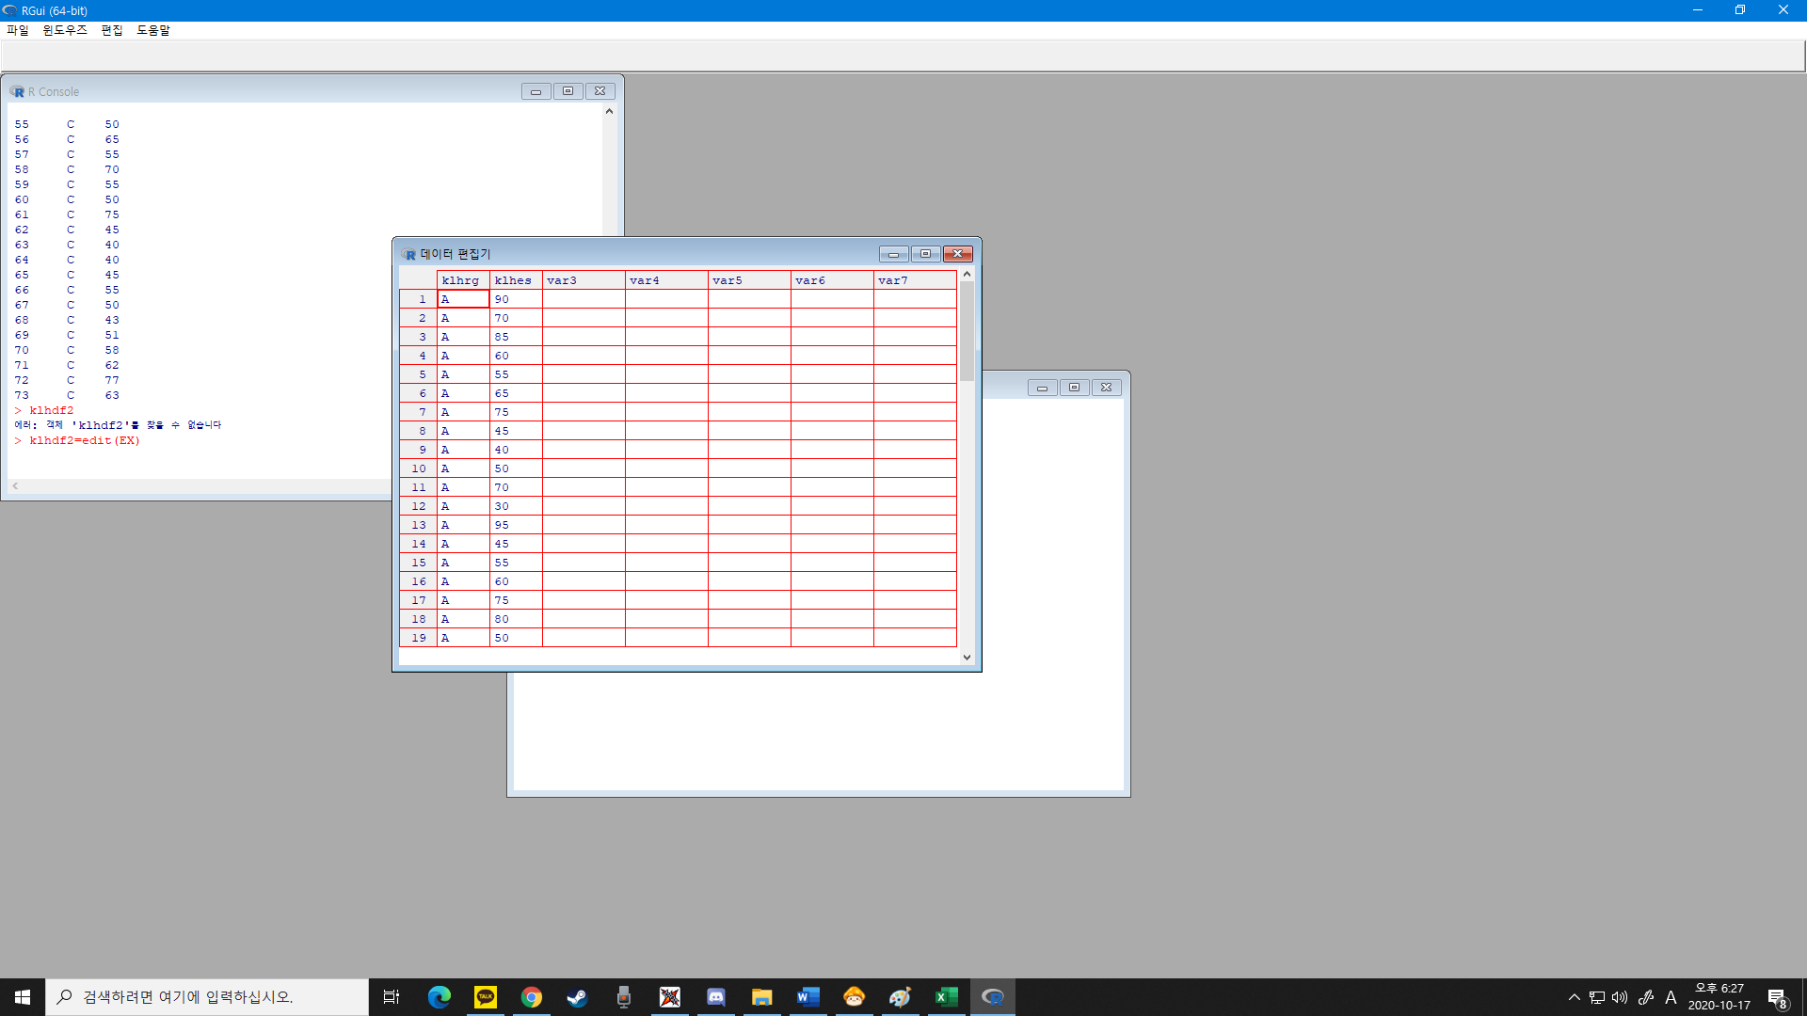

B(4)

> klhftb=klhdf2[klhdf2$klhrg=="B",]

> klhftb

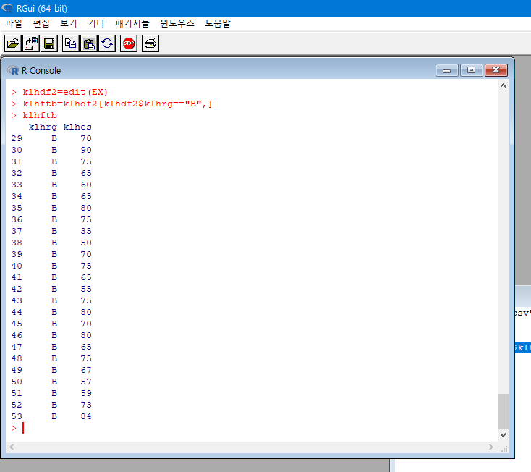

B(5)

> mean(klhftb$klhes)

[1] 68.6

> median(klhftb$klhes)

[1] 70

> var(klhftb$klhes)

[1] 138.75

> sqrt(var(klhftb$klhes))

[1] 11.77922

> quantile(klhftb$klhes)

0% 25% 50% 75% 100%

35 65 70 75 90

B(6)

> boxplot(klhdf2$klhes~klhdf2$klhrg)

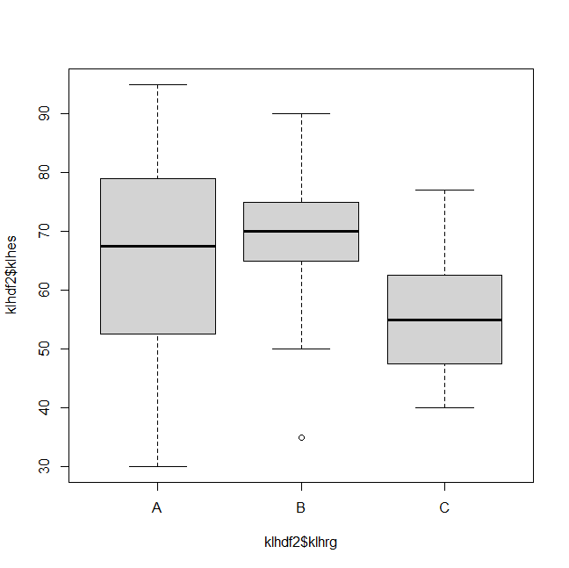

B(7)

> write.csv(klhdf2,"e:/김락형.csv")

